
Tripoli Motor Testing Division
223 NC Highway 54 West
Chapel Hill, NC 27514
(919) 357 5681 (c)
May 6, 2018

Gary Rosenfield
RCS Rocket Motor Components, Inc.
2113 West 850 North Street
Cedar City, UT 84721

Dear Mr. Rosenfield,

The Aerotech J435WS-13A DMS motor was tested on April 21, 2017, September 16, 2017, and May 3, 2018 and is in compliance with NFPA 1125. The motor is certified for hobby rocketry use by the members of the Tripoli Rocketry Association and all approving organizations with reciprocal certifying agreements.

Motor Manufacturer Aerotech Division, RCS Rocket Motor Components
Manufacturer’s Designation J435WS-13A DMS 38mm
Propellant Super White Lightning
TMT Nomenclature 743 J442

Diameter - 38 mm
Overall Length 14.406” 365.9 mm
Length Inside 14.035” 356.5 mm
Length Outside 0.370” 9.4 mm

Loaded Mass 1.359 lb 616.4 g
Propellant Mass 0.776 lb* 352 g*
Burnout Mass 0.532 lb 241.25 g
* data provided by manufacturer

Burn time 1.635 ± 0.094 sec

Total Impulse 166.98 ± 6.29 lbf.s 742.77 ± 27.97 N.s
Max Impulse 160.25 ± 36.63 lbf 712.85 ± 162.96 N
Average Impulse 99.28 ± 6.78 lbf 441.61 ± 30.14 N
Number of Motors Tested 13

Nominal Measured
Delay Time Data 6 7.217, 7.406, 7.085, 6.477 sec
10 10.415, 10.655, 10.047, 10.984 s
14 11.777, 13.333, 12.22, 12.989,12.531 sec

Casing Temp. [NFPA 1125 7.4.1] Passed
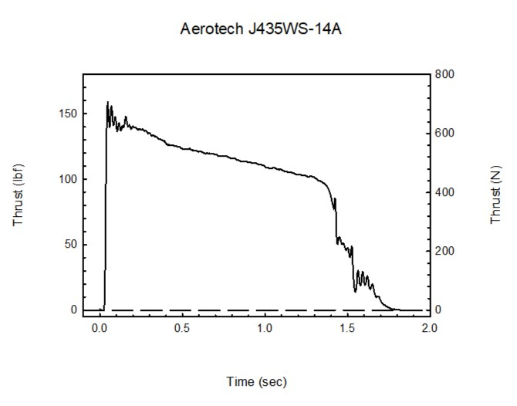Sincerely,

Alan C. Whitmore
Chair, Tripoli Motor Testing

